CSC 246 Project2

Junfei Liu(jliu137)

Stage One – SVMs

1. LinearSVM with various slack variable parameter

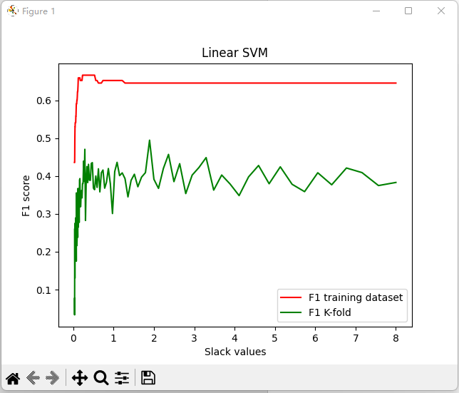

Maximum numerical observation:

F1 score on training set: 0.6666666666666666 with parameter 0.23004691265621877

accuracy score on training set: 0.8306878306878307 with parameter 0.125

F1 score on cross validation: 0.4766666666666667 with parameter 0.33915108186191795

accuracy score on cross validation: 0.7304409672830725 with parameter 0.33915108186191795

1. SVC rbf kernel with various slack variable parameter

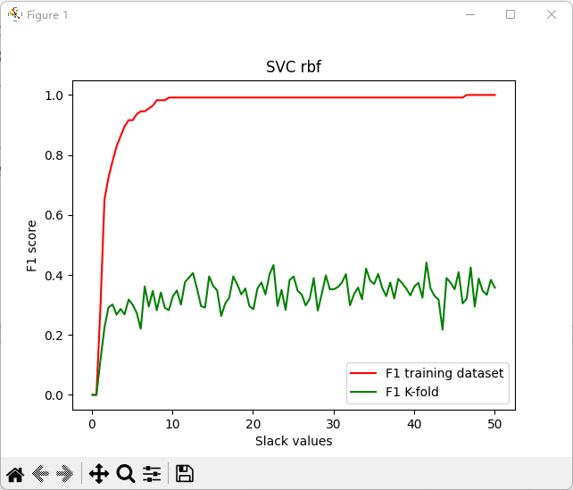

Maximum numerical observation:

F1 score on training set: 1.0 with parameter 46.507

accuracy score on training set: 1.0 with parameter 46.507

F1 score on cross validation: 0.44105627705627704 with parameter 41.517

accuracy score on cross validation: 0.7086770981507823 with parameter 1.098

1. SVC rbf kernel with various scale variable parameter

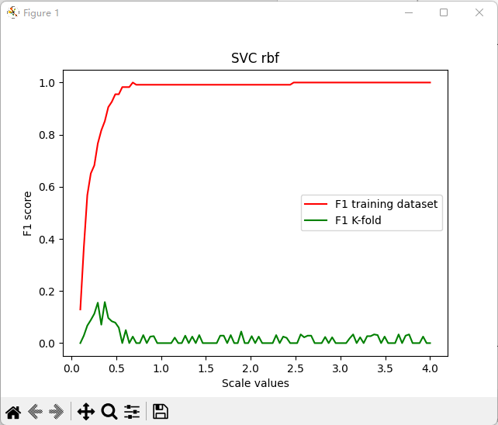

Maximum numerical observation:

F1 score on training set: 1.0 with parameter 0.6849999999999999

accuracy score on training set: 1.0 with parameter 0.6849999999999999

F1 score on cross validation: 0.15762032085561498 with parameter 0.373

accuracy score on cross validation: 0.7042674253200569 with parameter 0.373

1. Evaluation & Reflection

The LinearSVC model can not reach 100% accuracy and F1 score while the SVC with rbf kernel can.

Stage Two – MLPs